**✅ RMSE (Root Mean Squared Error) in Movie Recommendation**

**📘 What is RMSE?**

**RMSE** is a **performance metric** used to measure the **accuracy of predicted ratings** in recommender systems.

It tells **how far the predicted ratings are from the actual ratings** given by users.

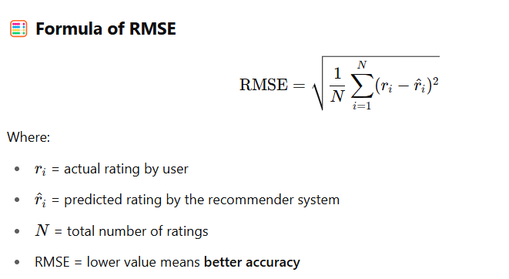

**🎬 Assume a Scenario: 5 Movies, 4 User Ratings**

| **Movie** | **Actual Rating rir_iri​** | **Predicted Rating r^i\hat{r}_ir^i​** |
| --- | --- | --- |
| Movie 1 | 4.0 | 3.5 |
| Movie 2 | 3.0 | 2.5 |
| Movie 3 | 5.0 | 4.5 |
| Movie 4 | 2.0 | 3.0 |
| Movie 5 | 1.0 | 1.5 |

Total number of ratings = 5  
So, N=5

**✏️ Step-by-Step RMSE Calculation**

Step 1: Find the squared errors

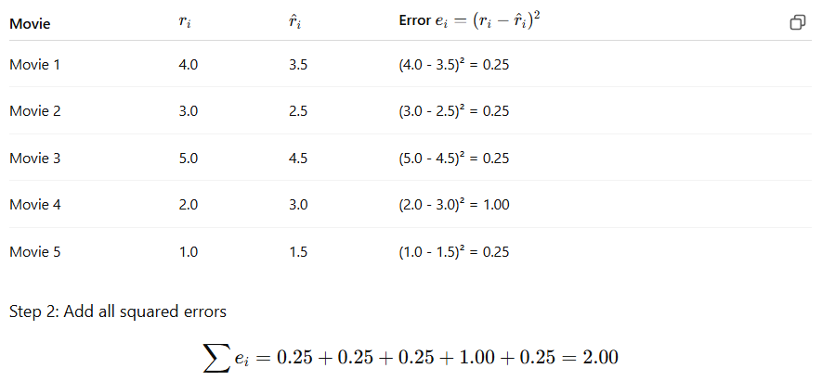

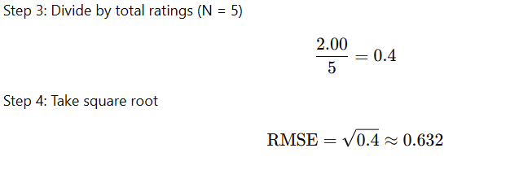

**✅ Final Answer:**

**🎯 Conclusion**

* RMSE helps us measure **how accurate** the predicted ratings are.
* In this example, an RMSE of **0.632** means the average prediction error is **less than 1 rating point**, which shows **good performance**.
* RMSE is widely used in **movie recommendations** and **collaborative filtering evaluations**.